Esteok Ahmed

Dr. Jayyousi, Thaer W.

BE 1600

1 December 2021

Project 1

Question 1

The usage of a dictionary to establish a mapping between the letters and their corresponding morse code is the challenge in problem 1. We loop over each letter in the user input and convert it to morse code, separating words with three whitespaces and letters with one whitespace. The input text is represented in morse code as the output. Converting morse code to regular text involves constructing a reverse dictionary mapping and obtaining the morse code to letter mapping. Iterate over the morse text, mapping each character to the appropriate letter. The letters that represent the input morse code are the output.

The code for importing the email from the text file is crucial in issue question 1. The letters and morse code mapping share a pattern, and we can get the precise position of the individual letters using a list slice. The converter function from normal to morse code utilizes the dictionary to translate each letter value to the matching morse code and returns the final code after the dictionary is filled. The reverse converter (from morse code to normal text) takes care of the inverse mapping and outputs normal text.

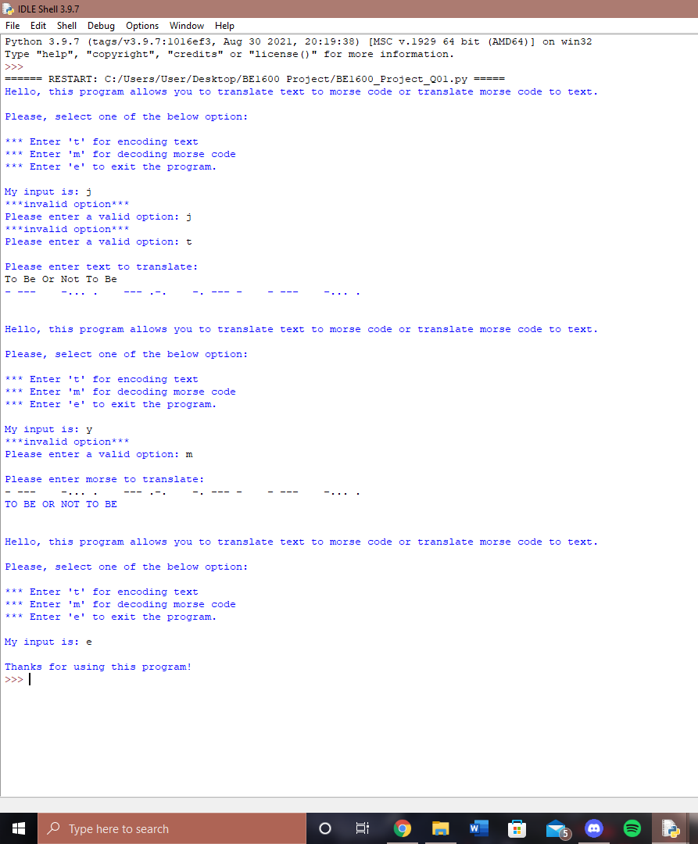

Question 2

In question 2, a mapping between the name and the address is created using the dictionary data structure. The menu enables data modification inside the dictionary to be specified. When you use the lookup email feature, you may enter a name and get both the name and the email address back. If the name does not already exist, add the email and address to the dictionary. The change email command changes an existing user's email address. The remove user command deletes all of a user's records. The name and/or email address are the inputs, and the output is a success or error message.

The load email function is responsible for generating the vocabulary that will be utilized in the function. To verify that the text file is not empty, a check must be done. The add email feature checks to see if the name and email address are already in use, and if they aren't, it creates the pair. Existing records are deleted when you send a deleted email. The lookup email verifies the existence of the name and returns both the name and the email address. The main program controls the application's functionality and allows the user to interact with the menu until they quit.

